PRESS RELEASE
COMMUNICATIONS AND MEDIA TEAM OF THE 43RD ASEAN SUMMIT 2023
No.120/SP/TKM-ASEAN2023/ENG/9/2023

43rd ASEAN Summit Gala Dinner Menu Written in 13 Languages

JAKARTA, 8 September 2023 – The 43rd ASEAN Summit Gala Dinner that took place at the Gelora Bung Karno City Forest, Senayan, Jakarta, on Wednesday, 6 September 2023 featured something unique.
It is usual for the menu served at various international events to be written in English as an international language.
However, its’s not the case with the Gala Dinner this time. In addition to English, the menu of the 43rd ASEAN Summit Gala Dinner was written in the 12 national languages of the invited guests, namely Portuguese, Italian, Arabic, Bengali, Mandarin, Japanese, Korean, Russian, Vietnamese, Tagalog, Laotian, and Cambodian (Khmer).
According to Siti Nugraha Mauludiah , the Foreign Affairs Minister’s Expert Staff for Social, Cultural, and Indonesian Community Empowerment Abroad, the menu written in 12 languages is an expression of Indonesia's appreciation for the attendance of ASEAN Leaders and ASEAN strategic partners at the 43rd ASEAN Summit.
"For guests with non-English national language, we provide a translation into their national language. This is the very first time this has ever been done," she said when contacted by the Communications and Media Team of the 43rd ASEAN SUMMIT 2023, on Friday, 8 September 2023.
At the 43rd ASEAN Summit Gala Dinner, Heads of State/Government and invitees were served a menu with the theme “Nusantara the Forest” that incorporated cuisine from a number of Indonesian regions. Andaliman crab from North Sumatra, Beef sweet soy sauce from Java, nasi campur (mixed rice) from West Sumatra and Rawon from East Java are among the menu items.
Meanwhile, for dessert there was Nusantara Urban Forest (IKN) consisting of chocolate, spiced banana, jasmine apple, and matcha moss (green tea sauce).
During the Dinner, the invited guests also can enjoy various performances by Indonesian musicians. The performance was divided into four segments, each with its theme: the Sound of Indonesia, "the Soul of ASEAN", "the Wave of Tomorrow", and "the Epicentrum of Growth".
***
For more information, please contact:
Director General of Public Information and Communications of the Ministry of Communications and Informatics – Usman Kansong (0816785320).
Get more information at http://asean2023.id, https://infopublik.id/kategori/asean-2023, and https://indonesia.go.id/kategori/ragam-asean-2023

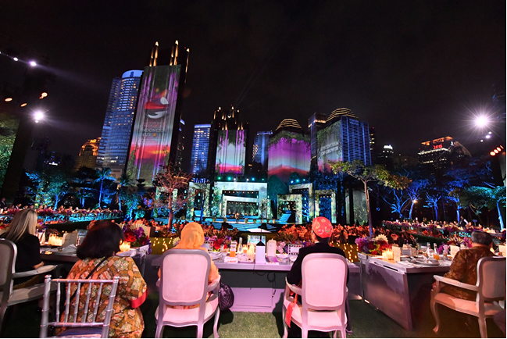
Indonesian President Joko Widodo and First Lady Iriana Joko Widodo watching a performance during the Gala Dinner of the 43rd ASEAN Summit at the Plataran City Forest, GBK Complex, Senayan, Jakarta, Wednesday, 6 September 2023. Media Center of the 2023 ASEAN Summit/Agus Suparto/pras.

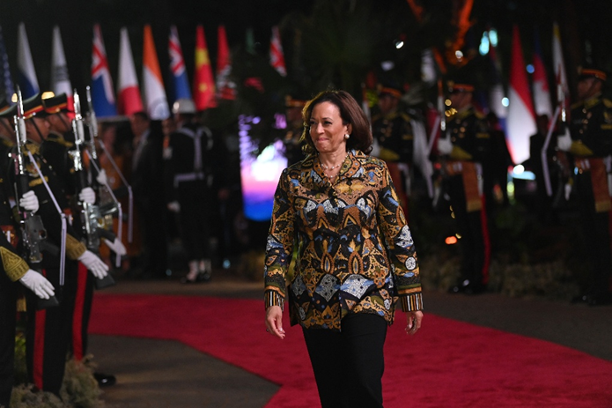
United States Vice President Kamala Harris attends the Gala Dinner of the 43rd ASEAN Summit at Plataran City Forest, GBK Complex, Senayan, Jakarta, Wednesday, 6 September 2023. 2023 ASEAN Summit Media Center/Aditya Pradana Putra/aww.

